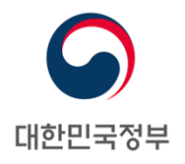
PERMANENT MISSION OF THE REPUBLIC OF KOREA
GENEVA
The 26th Session of UPR Working Group Review of Uganda
Geneva, 3 November 2016

Statement of the Republic of Korea

Mr. Vice President,

While joining others in welcoming the delegation of Uganda, the Republic of Korea commends Uganda’s commitment to promoting and protecting human rights by establishing the National Action Plan on Human Rights.

In addition, my delegation takes note of Uganda’s implementation of the Second National Development Plan, which will ensure human rights-based approach of development and achievement of the sustainable development goals (SDGs).

My delegation would like to offer the government of Uganda the following recommendations:

- Extend a standing invitation to all Special Procedures mandate holders; and

- Fully implement the National Gender Policy Action Plan.

We hope that our recommendations will contribute to adding momentum for Uganda to further improve human rights situation in the country. We wish Uganda a successful review process.

Thank you, Mr. Vice President. /End/

